CITY OF WINNFIELD
SPECIAL MEETING
January 18, 2024

The special meeting of the Mayor and City Council was called to order at 5:05 p.m. on Thursday, January 18, 2024, by Mayor Gerald Hamms. Those present in addition to Mayor Hamms were Councilpersons Hall-Dudley, Caldwell, Miller, Phillips, Breda, Katina Smith, City Clerk., and Attorney Herman Castete.

- Call to Order – 5:05

- Agenda Amendments (if any)
None
- Old Business- Action Items
None
- Old Business- Non-Action Items
None
- New Business-Action

- Introduce Ordinance-4 of 2024- Lamats collection of occupational insurance taxes- Breda.

The following Ordinance was introduced by Councilperson Breda at the special meeting of the Mayor and City Council of the City of Winnfield, Louisiana held on January 18, 2024, to-wit:

ORDINANCE NO. 4 of 2024

AN ORDINANCE TO PROVIDE FOR THE IMPOSITION OF A TAX ON INSURANCE PREMIUMS, AS AUTHORIZED BY L.R.S 22:833 AND 22:8:34, AND TO PROVIDE FOR RELATED MATTERS. AND PROVIDING AN EFFECTIVE DATE THEREFOR.

The above ordinance will be considered for adoption at the special scheduled meeting of the Mayor and City Council of the City of Winnfield to be held January 31, 2024.

- Approve agreement for LAMPS- Miller
Discussion was had by the Mayor and Council.
Motion by Council person Miller and seconded by Council person Caldwell thereafter the following vote was recorded.
Yeas: 1 (Breda,)
Nays: 3 (Phillips, Miller, Caldwell)
Abstained: 0
Absent: 0

- Approve Winn Community Subdivision- Miller
On a Motion by Councilperson Miller duly seconded by Dudley after no public comment, the Council unanimously voted to approve Winn Community Subdivision
Yeas: 5 (Phillips, Miller, Hall-Dudley, Breda, Caldwell)
Nays: 0
Abstained: 0
Absent: 0

- Approve cooperative endeavor agreement for Winn Community Garden- Hall-Dudley
Cooperative Endeavor Agreement: HYPE Community Garden
Parties:
This Agreement is entered into on January 22, 2024, by and between:
Party A: LSIJ AgCenter - Winn Parish, 1 19 W. Main St., Ste. 4, Winnfield, LA, 71483
Party B: Steve Shelton, P.O. Box 1437 Winnfield, LA 71483
Party C: City of Winnfield, 120 E. Main St., Winnfield, LA 71483
Party D: Winn Parish Master Gardeners, 1 19 W. Main St., Ste. 4, Winnfield, LA, 71483
Party E: Winnfield Senior High School FFA, 631 Thomas Mill Rd, Winnfield, LA 71483
Collectively referred to as the "Parties."
Purpose:
The Parties agree to collaborate on creating a Community Garden and Educational Space growing fresh fruit and vegetables to offset food insecurity. The primary objective is to develop an educational center where programs can be conducted to educate citizens in a neutral meeting space to develop a healthier parish population.
Scope of Work:
The space will be two to three city blocks set aside to develop an educational Community Garden for Winn Parish citizens, allowing food supplies for those living in food deserts.
Each Party's responsibilities and contributions to the collaboration are detailed in Exhibit A attached hereto.
LSU AgCenter -Winn Parish:
- Provide educational activities.
- Help with layout of the site.
- Help with the construction of needed beds and facilities.
- Oversee planning and construction plans.
Steve Shelton
- Provide location to construct the project.
- Provide grass/weed manicure.
City of Winnfield
- Provide water for the garden as an in-kind service to citizens.
Winn Parish Master Gardeners
- Provide assistance with educational programs and activities.
Winnfield Senior High School FFA
- Construct Community Garden Beds and other projects
- Assist with educational programming and activities Assist with layout of site.
Term:
This Agreement shall commence on January 10, 2024, and the project will continue until perpetuity unless terminated earlier as provided herein.
Financial Contributions:
The Parties will not have any financial responsibilities. This project will be entered into by in-kind donations/agreements.
Intellectual Property:
Educational materials utilized at this site will be research based provided by LSI-J AgCenter.
Confidentiality:
The Parties agree to maintain the confidentiality of any proprietary information shared during the collaboration.
Termination:
Either Party may terminate this Agreement upon written notice if any of the Parties breaches a material term.
Dispute Resolution:
Any disputes arising out of or in connection with this Agreement shall be resolved through a meeting of the five parties.
Governing Law:
This Agreement shall be governed by and construed in accordance with the laws of the State of
Louisiana.
Amendments:
Any amendments to this Agreement must be in writing and signed by all Parties.
IN WITNESS WHEREOF, the Parties hereto have executed this Cooperative Endeavor Agreement as

of the date first above written.
Party A: oJcC)// Date: 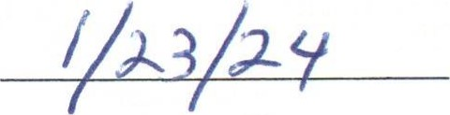
LSU AgCenter-Winn Parish  Party B: Steve Shelton Date:  Party C City of Winnfield - Mayor Gerald Hamms Date:  Party D Winn Parish Master Gardeners Date: | 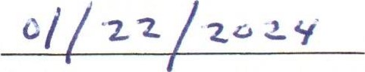
 | 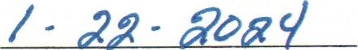
 | 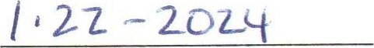
Party E: Date: 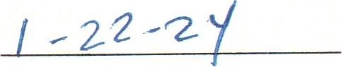

On a Motion by Councilperson Hall-Dudley duly seconded by Caldwell after no public comment, the Council unanimously voted to approve the cooperative endeavor agreement for Winn Community Garden
Yeas: 5 (Phillips, Miller, Hall-Dudley, Breda, Caldwell)
Nays: 0
Abstained: 0
Absent: 0

- New Business- Non-Action Items

- Councilperson Miller called for the executive session.
The Mayor and Council entered executive session at 5:29 p.m.

The Mayor and Council exited executive session at 6:02 p.m. and reconvened at 6:03 p.m.to continue with the meeting.
On motion by Councilperson Miller and seconded by Councilperson Caldwell, with following vote:

Yeas: 5 (Phillips, Miller, Hall-Dudley, Breda, Caldwell)
Nays: 0
Abstained: 0
Absent: 0

- The Mayor and Council discussed Gold Weems Law Firm to proceed in response to plaintiff discovery for the Po’boys vs. City of Winnfield.

- Adjournment

On motion by Councilperson Caldwell, duly seconded by Councilperson Miller, after no public comment, the Council unanimously voted to adjourn the meeting January 18, 2024, at 6:10 p.m.

Gerald Hamms Katina Smith
_______________ _____________________

Gerald Hamms, Mayor Katina Smith, City Clerk

