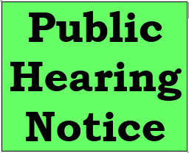

A public hearing will be held by the Mayor and City Council of the city of Winnfield, Louisiana at the A. Leonard Allen Building, Winnfield, Louisiana on June 27,2024 at 4:00pm. The purpose of this hearing is to discuss the proposed (amended) budget for the city of Winnfield, Louisiana for the fiscal year July 1, 2023-June 30, 2024, and to discuss the proposed budget for the fiscal year July 1, 2024-June 30, 2025.
The amended and proposed budgets may be examined Monday through Friday at the Mayor’s office, City Hall, Winnfield, Louisiana between the hours of 8 a.m. and 4 p.m. All interested citizens will have the opportunity to give written and oral comments. Senior citizens are encouraged to attend and comment.

